System Design

System design is the process of defining the architecture, components, modules, interfaces and data for a system to satisfy specified requirements through system modelling. It can also be seen as the application of systems theory to produce development. The design of this system will be user friendly. It shall be designed in such a way that employees will be able to navigate easily through the information supplied on the system.

Agile Approach

The agile approach is a software development approach based on values, principles, and core practices. The four values are communication, simplicity, feedback, and courage.

When these four control variables are properly included in the planning, there is a state of balance between the resources and the activities needed to complete the project.

EXPLORATION
During exploration, you will explore your environment, asserting your conviction that the problem can and should be approached with agile development, assemble the team, and assess team member skills.

PLANNING
The next stage of the agile development process is called planning. In contrast to the first stage, planning may only take a few days to accomplish. In this stage you and your customers agree on a date anywhere from two months to half a year from the current date to deliver solutions to their most pressing business problems

ITERATIONS TO THE FIRST RELEASE
The third stage in the agile development process is composed of iterations to the first release. Typically these are iterations of about three weeks in duration. You will be pushing yourself to sketch out the entire architecture of the system, even though it is just in outline or skeletal form. One goal is to run customer-written functional tests at the end of each iteration.

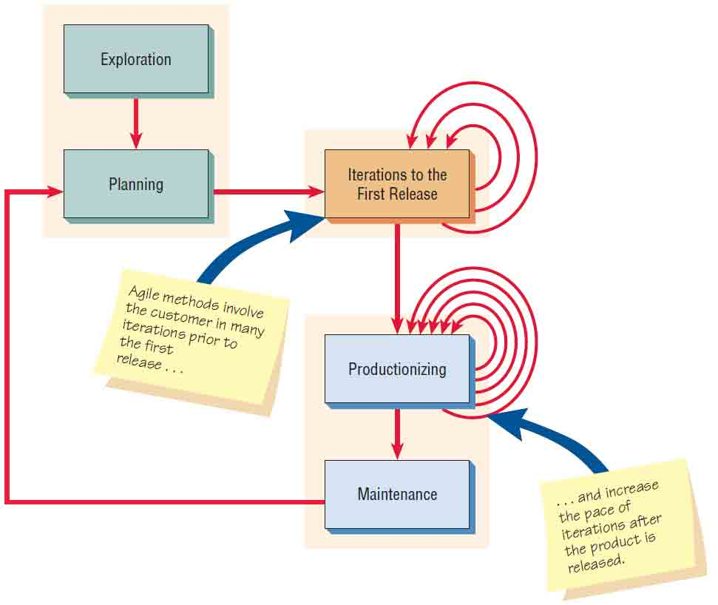

PRODUCTIONIZING
Several activities occur during this phase. In this phase the feedback cycle speeds up so that rather than receiving feedback for an iteration every three weeks, software revisions are being turned around in one week. You may institute daily briefings so everyone knows what everyone else is doing. The product is released in this phase, but may be improved by adding other features.

MAINTENANCE
Once the system has been released, it needs to be kept running smoothly. New features may be added, riskier customer suggestions may be considered, and team members may be rotated on or off the team. The attitude you take at this point in the developmental process is more conservative than at any other time.

